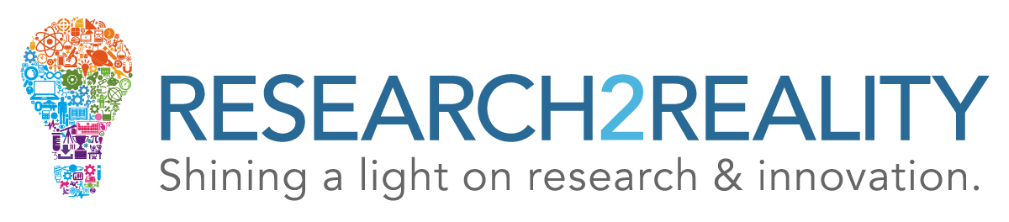

It's All In Our Heads
An Interview with Neuroscientists: Professors Melvyn Goodale, Adrian Owen, and Lisa Saksida at Western University
Canadian Institute for Advanced Research

Why research consciousness?

Melvyn Goodale

The Azrieli Program in Brain, Mind and Consciousness is a new program at CIFAR, at the Canadian Institute for Advanced Research, which focuses on how the brain gives rise to mind. How it is that three pounds of wetware inside our skull gives rise to how we think deeply about the world, how we make decisions, how we create art and enjoy art, all of those kinds of things that are particularly human.

Adrian Owen

We’re starting to close the gap between brain and mind, and one of the great things we’re showing in this program is that, you know, one is directly the product of another. It’s not that we have a brain and we have a mind, it’s that our brain produces our sense of having a mind. You know that’s very exciting to me because we’re really starting to work at exactly where our sense of being us comes from.

Lisa Saksida

We really know very little about how activity in the brain leads to high-level cognition and consciousness. So from a sort of fundamental science perspective, it’s also a fascinating question. My view is that once we understand all these different aspects of easy questions, I think we’re going to be much closer to understanding the hard problem which is how is it, why is it that we experience the world in the way that we do.

Melvyn Goodale

I think it’s important that we understand how the brain gives rise to mind in the same way that it is important, fundamentally, to understand the origin of the universe. It’s a kind of deep question, in this case, about human nature, that we really need to understand as curious creatures on this planet.

How does studying consciousness impact society?

Adrian Owen

One of the things that we have managed to do recently is to actually communicate with some patients who are soon to be vegetated, while they are lying in the MRI scanner. Now to do that is a tremendous technical achievement, I think. We all think about consciousness in different ways, but broadly, when we talk about consciousness, we’re thinking about wakefulness – having your eyes open and being awake – and something like awareness. Aware of who we are and aware of where we are. And those two components of consciousness are aspects that we have tried to work out how best to measure.

Melvyn Goodale

Clearly there’s the importance of understanding how patients with different kinds of brain damage can be left with different kinds of problems in cognition, in memory, in sensory processing and motor control, and so on. But at the same time, there are lessons that engineers can learn from how the brain works when controlling our complex movements, how the brain works in solving problems, there are lessons there for engineers, for people working in computer science, from artificial intelligence.

Lisa Saksida

I come from a very applied perspective in some senses. I want to be able to understand how we can treat diseases like Alzheimer’s Disease – and Alzheimer’s Disease is one of the biggest problems facing our society at the moment with our aging population and I think the only way that we’re going to be able to develop effective treatments is to have a fundamental understanding of the brain circuits that are involved in the aspects of cognition that are affected in Alzheimer’s Disease.

Adrian Owen

At some point, from us being, you know, a tiny organism made up of a few cells to being a fully grown adult, consciousness emerges at some point along that line. And we have absolutely no idea where does it come from, when does it start to emerge, how does it emerge? And those are the sorts of big questions we are putting to our CIFAR group to say “let’s start thinking about this because this is a practical problem we should be able to solve.”

